Day 1 Lab Assignments
Do the following Assignments (Try to make your pages HTML5 valid, and don’t use deprecated tags or attributes):
- Start to create your personal website, create new folder that will contains all site pages and another new folder inside it for website resources (images, media,...).
- Create welcome page and name it (welcome.html) that contains a welcome statement and your name in new line, and welcome image on the center of the page.
  - Change the font and color of the welcome statement.
  - Change the background color of the page.
  - Make the page after 5 seconds; redirect the user to another page named (Home.html).
  - Make (skip Intro) link on the center bottom of the page that skips welcome page, and opens (Home.html) page in the same browser window.
- Create the Home page and name it (Home.html), and add the following on it (as shown in the image below):
  - Add your Name in the center of the page as the page main header
  - Add your personal information in bullet list on the left.
  - Then put your personal photo (on the right),
  - Finally add a brief about yourself (Make a long text on about me, to show vertical scroll on the page, and so you need to scroll to reach the end of the page)
  - Change your name to be in Arabic?
    - You need to use meta tag to change the page character encoding, what is it?
  - Add horizontal line after “about me” section, and then Create div in the bottom of home page (after the horizontal line) include 3 links (Home, About, Contact me) to (top part of home page (bookmark), page named About.htm, page named Contact.htm).
  - In the footer add your social media links (each one is an image link, when clicked opens the clicked social profile in a new window).
  - Handle the below image, to be a link to the top of page (Bookmark).
  - The home page should look as the following after you finish it:
Your Full name
My personal info:

Personal Photo
- Age:
- Address:
- Phones:
- Faculty name (as a link to your faculty website, that opens in a new window)
- Graduation year
- Hobbies

- Send me Email (Mail Link)

About me:

home contact us about

Copyrights © are reserved to ITI.

- Follow these guidelines in your home page:
  - Use <title> tag.
    - What’s the importance of using <title> tag? And how it’s related to SEO?
  - Use meta – charset tag. (Why?).
  - Use meta – viewport tag. (Why?).
  - Use meta – description tag.
    - What are its benefits? And how it’s related to SEO?
  - Set a favicon for your page.
- Create new page and name it (About.htm), and write about yourself using text formatting and appearance tags (Try to not use deprecated tags, and use “style” attribute instead).

Self-Study Assignments (Bonus):
- Replace any deprecated tags and attributes in your pages to be HTML5 Valid.
- Put a back ground sound on (welcome page), that runs automatically when the page loads (use audio tag).
  - Most browsers are blocking the auto play sound in pages currently; in this case you can make the audio start by user normally.
- Replace the image in the welcome page, to be a full-page background image (like this one: https://www.w3schools.com/howto/tryhow_css_fullpage_demo.htm )
- Display a video in your home page in any place (use video tag).
  - Try to make the video as Fullscreen Video Background in home page or welcome page (like this one here: https://www.w3schools.com/howto/howto_css_fullscreen_video.asp )
- Set a favicon for your page.
- Try iframe on your home page.
- Design a single page website like the following (You can make it as a personal CV for yourself):
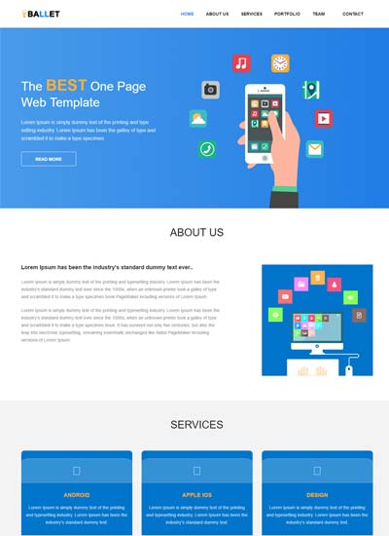
- Use Image map in new page.
- What are Back-links? (With example)
- What’re meta tags? And what’re its benefits and uses? (With example)
- What are the meta tags for social media? And what are its uses? (With example)
- What are search engines? And how it work?
- What’s SEO?
- How to optimize your website for search engines?

<Thank> YOU </Thank>

